Palindrome Number
Platform: Leetcode
Language: C
Module 4, Question 5

Problem Link
https://leetcode.com/problems/palindrome-number/description/

Problem Statement
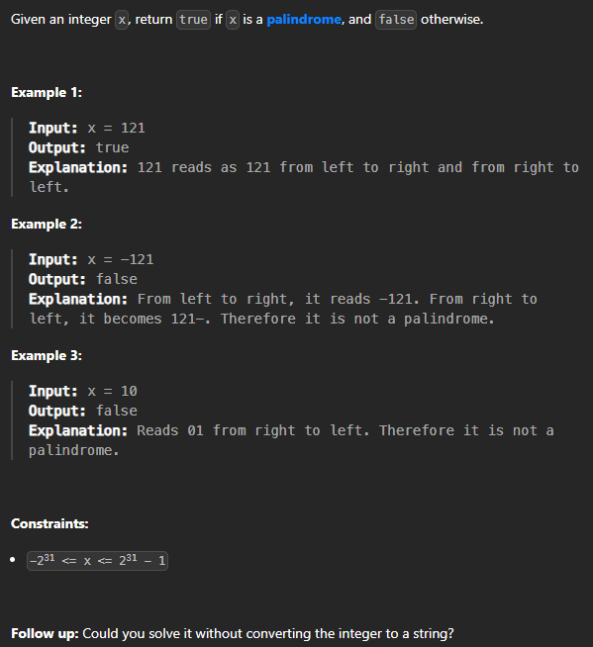

C Code
bool isPalindrome(int x) {
if (x < 0) return false; // negative numbers are never palindromes

long long reversed = 0;
int temp = x;
while (temp > 0) {
reversed = reversed * 10 + temp % 10;
temp /= 10;
}
return reversed == x;
}

Screenshot of Successful Submission



